# How we deploy Scrum practices?

Since the beginning of our project we decided to use Scrum as methodology for the project management. We adopted user stories as our requirements management system and prioritized those requirements, estimated their complexity and once we gathered the project’s requirements divided them into 3 sprints. But due to the size of the project and context in which this is been developed we adapted part of the scrum process for example we are holding scrum meetings twice a week instead of daily.

# Release Plan

## Increment Plan

|  |  |  |  |  |  |
| --- | --- | --- | --- | --- | --- |
| Incr. | Start | Days | End | Size | Status |
| 1 | 17.10.2012 | 8 | 24.10.2012 | 8 | Released |
| 2 | 25.10.2012 | 14 | 7.11.2012 | 14 | Released |
| 3 | **8.11.2012** | **10** | **17.11.2012** | **10** | **Ongoing** |

## Sprint Plan

|  |  |  |  |  |  |
| --- | --- | --- | --- | --- | --- |
| Sprint | Start | Days | End | Size | Status |
| 1 | 12-10-17 | 8 | 12-10-24 | 8 | Released |
| 2 | 12-10-25 | 14 | 12-11-07 | 14 | Released |
| 3 | **12-11-08** | **10** | **12-11-17** | **10** | **Ongoing** |

# Product Backlog

|  |  |  |  |  |  |
| --- | --- | --- | --- | --- | --- |
| Story ID | Story name | Status | Size | Sprint | Priority |
| US1 | Signing Up | Planned | 2 | 1 | High |
| US2 | Courses Creation | Planned | 4 | 1 | High |
| US6 | Find Courses | Planned | 2 | 1 | High |
| US3 | Course Registration | Planned | 2 | 2 | High |
| US5 | Notification | Planned | 4 | 2 | Medium |
| US7 | Course Rating and Comments | Planned | 4 | 2 | Low |
| US8 | Tutor Rating and Comments | Planned | 4 | 2 | Low |
| US4 | Schedule Availability | Planned | 6 | 3 | Medium |
| US9 | Publishing Schedule | Planned | 4 | 3 | Medium |

# Product Backlog Burndown Chart

|  |  |  |  |  |
| --- | --- | --- | --- | --- |
| Original planned size | |  | 3 |  |
| Count trend from last | |  | 2 | sprints |
|  |  |  |  |  |
| **Velocity (points per sprint)** | | |  |  |
| Original estimate | |  | 32 |  |
| Last 2 sprints | |  | 7.0 |  |
| Realized total average | |  | 7.3 |  |
| Average last 8 | |  | 7.3 |  |
| Avg. worst 3 in last 8 | |  | 7.3 |  |

|  |  |  |  |  |
| --- | --- | --- | --- | --- |
| Sprint | Remain.  Work | Planned Work | Realized Work | Current Total Size |
| 1 | 32 | 8 | 8 | 40 |
| 2 | 24 | 14 | 14 | 32 |
| 3 | 10 | 10 | 0 | 32 |

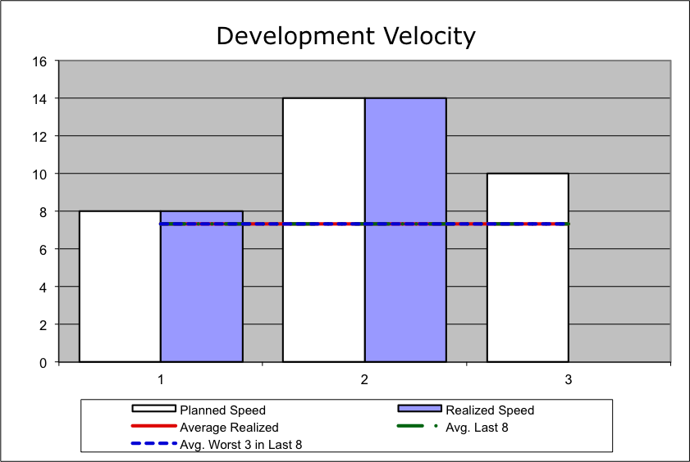

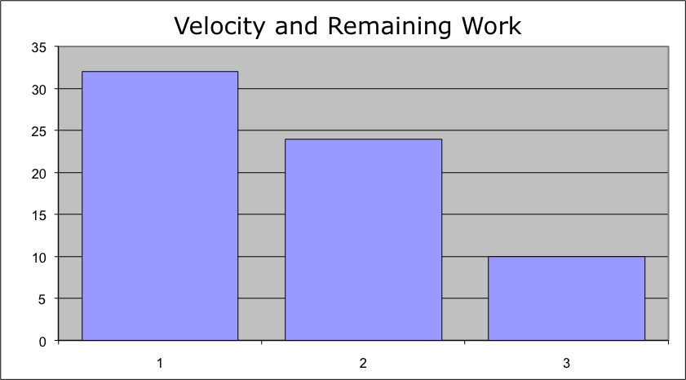

# Sprint 1 Backlog

|  |  |  |  |  |  |  |  |  |  |  |  |  |
| --- | --- | --- | --- | --- | --- | --- | --- | --- | --- | --- | --- | --- |
| Sprint implementation days | 8 |  |  | **Effort** | **Remaining on implementation day…** | | | | | | |  |
| Trend calculated based on last | 8 | **Days** | **Totals** | **8** | **8** | **7** | **6** | **5** | **3.5** | **2.5** | **1.5** | **0.5** |
| Task name | **Story ID** | **Responsible** | **Status** | **Est.** | **1** | **2** | **3** | **4** | **5** | **6** | **7** | **8** |
| Signing Up | US1 | Pedro | Done | 2 | 2 | 1.5 | 1 | 0.5 | 0 | 0 | 0 | 0 |
| Courses Creation | US2 | Ray | Done | 4 | 4 | 3.5 | 3 | 2.5 | 2 | 1.5 | 1 | 0.5 |
| Find Courses | US6 | Wynn | Done | 2 | 2 | 2 | 2 | 2 | 1.5 | 1 | 0.5 | 0 |

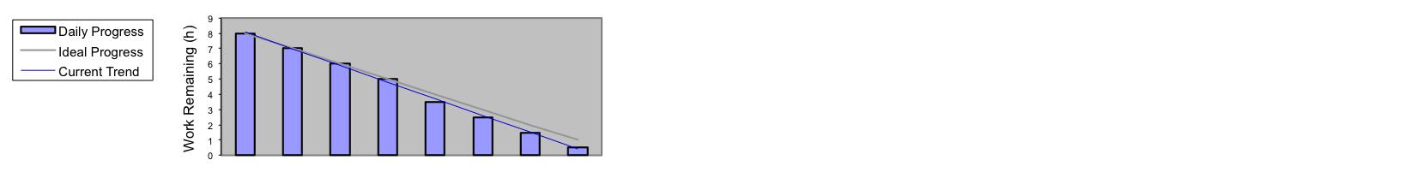

# Sprint 2 Backlog

|  |  |  |  |  |  |  |  |  |  |  |  |  |  |  |  |  |  |  |
| --- | --- | --- | --- | --- | --- | --- | --- | --- | --- | --- | --- | --- | --- | --- | --- | --- | --- | --- |
| Sprint implementation days | 14 |  |  | Effort | Remaining on implementation day… | | | | | | |  |  |  |  |  |  |  |
| Trend calculated based on last | 14 | **Days** | **Totals** | **14** | **14** | **12.5** | **12** | **10.5** | **8.5** | **7** | **5.5** | **4** | **2.5** | **1** | **0.5** |  |  |  |
| Task name | **Story ID** | **Responsible** | **Status** | **Est.** | **1** | **2** | **3** | **4** | **5** | **6** | **7** | **8** | **9** | **10** | **11** | **12** | **13** | **14** |
| Course Registration | US3 | Ray | Done | 2 | 2 | 1.5 | 1 | 0.5 | 0 | 0 | 0 | 0 | 0 | 0 | 0 | 0 | 0 | 0 |
| Notification | US5 | Wynn | Done | 4 | 4 | 4 | 4 | 4 | 3.5 | 3 | 2.5 | 2 | 1.5 | 1 | 0.5 | 0 | 0 | 0 |
| Course Rating and Comments | US7 | Pedro | Done | 4 | 4 | 3.5 | 3.5 | 3 | 2.5 | 2 | 1.5 | 1 | 0.5 | 0 | 0 | 0 | 0 | 0 |
| Tutor Rating and Comments | US8 | Pedro | Done | 4 | 4 | 3.5 | 3.5 | 3 | 2.5 | 2 | 1.5 | 1 | 0.5 | 0 | 0 | 0 | 0 | 0 |

